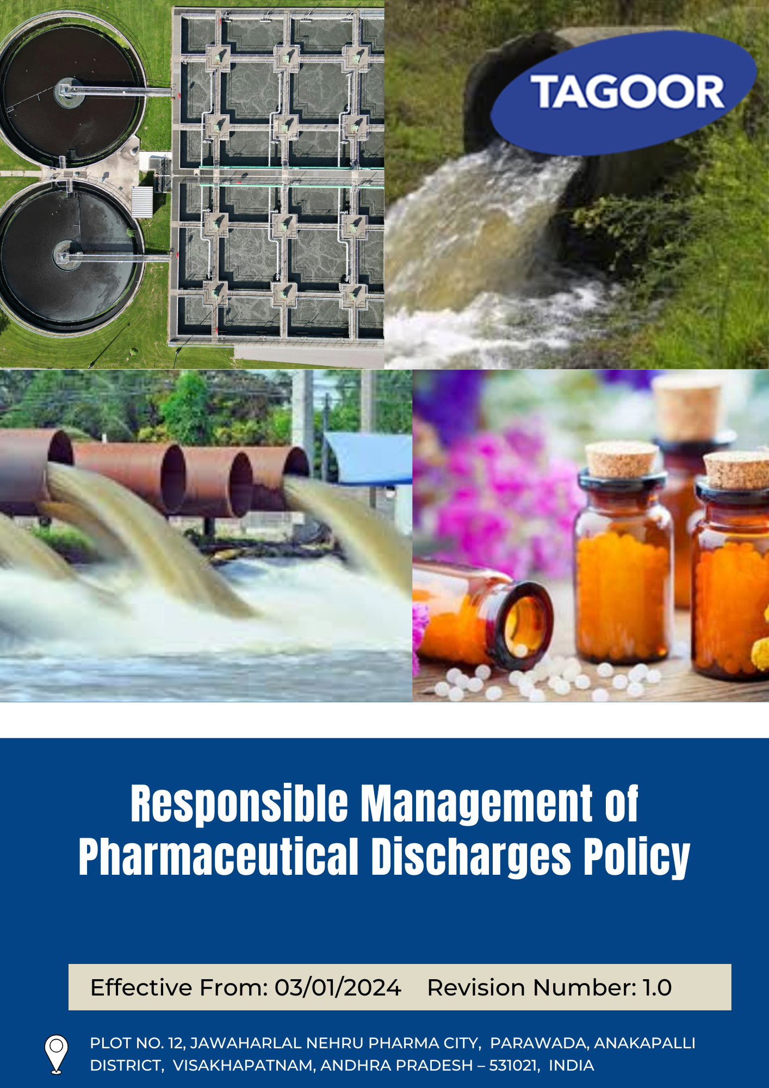

INDEX
1. About this Policy 3
2. Scope & Applicability 3
3. Tagoor’s Vision and Approach to Responsible Management of Pharmaceutical Discharges 3
4. Discharge Management Objectives 4
5. Organizational Responsibilities 4
6. Tagoor’s Responsible Pharmaceutical Discharges Targets 5
7. Tagoor’s Responsible Pharmaceutical Discharges key strategies 6
8. Covered Sustainable Development Goals (SDGs) 6
9. Environmental Performance Monitoring and Reporting 6
10. Emergency Response & Spill Management 7
11. Review Mechanism 8
12. Employee Acknowledgement & Commitment Declaration 9

About this Policy
This Responsible Management of Pharmaceutical Discharges Policy (“Policy”) is established by Tagoor Laboratories Pvt. Ltd. (“the Company”) to effectively manage and control the discharge of pharmaceutical substances, including active pharmaceutical ingredients (APIs), arising from its operations in the pharmaceutical and chemical manufacturing sector.

The Company is committed to integrating responsible discharge management into its operations, business planning, and stakeholder engagement processes. This Policy outlines the Company’s objectives, key focus areas, performance expectations, and mechanisms for monitoring, evaluation, and continuous improvement in managing pharmaceutical discharges.

The Company has adopted appropriate technologies, treatment systems, and operational controls to minimize the release of pharmaceutical residues into the environment and to ensure responsible and sustainable operational practices across all levels of the organization.

Scope & Applicability
This Policy applies to all operations, activities, and facilities of Tagoor Laboratories Pvt. Ltd. (“the Company”). It is applicable to all employees at all levels, as well as contractors, suppliers, service providers, business partners, and any other individuals or entities working on behalf of the Company.

Company | Registered Address
Tagoor Laboratories Pvt Ltd | Plot No. 12, Jawaharlal Nehru Pharma City, Parawada, Anakapalli District, Visakhapatnam, Andhra Pradesh – 531021, India.

Tagoor’s Vision and Approach to Responsible Management of Pharmaceutical Discharges

The Company has adopted a structured approach to pharmaceutical discharge management based on the following principles:

- Prevent: Potential sources of pharmaceutical discharges shall be identified, assessed, and controlled at the planning and operational stages through appropriate process design, containment measures, and handling practices.
- Comply: The Company shall comply with all applicable environmental laws, regulations, and statutory requirements related to effluent discharge and pharmaceutical residue management, and shall align its practices with relevant industry standards.
- Improve: The Company shall strive for continuous improvement in managing pharmaceutical discharges through monitoring, evaluation, and implementation of effective treatment technologies and operational controls.

Discharge Management Objectives
- To manage and control pharmaceutical discharges, including active pharmaceutical ingredients (APIs), through appropriate operational practices and treatment measures.
- To minimize the release of pharmaceutical residues into the environment through effective process controls and effluent treatment systems.
- To ensure compliance with applicable environmental laws, regulations, and standards related to pharmaceutical discharge and wastewater management.
- To promote awareness and responsibility among employees and relevant stakeholders regarding safe handling and discharge of pharmaceutical substances.
- To adopt appropriate technologies, treatment systems, and best practices to manage pharmaceutical discharges effectively.
- To support continuous improvement in discharge management through regular monitoring, evaluation, and performance review.

Organizational Responsibilities
The following roles and responsibilities apply across the organization:
Role | Designation | Key Responsibilities
Senior Management | Managing Director | Provide strategic oversight of the Responsible Management of Pharmaceutical Discharges Policy; ensure alignment with business objectives; allocate financial, technical, and human resources; engage with regulators and industry bodies; oversee risks related to API discharge and environmental impact
Environmental Manager | Environment Officer | Implement and review the Responsible Management of Pharmaceutical Discharges Policy; coordinate programs related to effluent treatment, API control, and discharge monitoring; ensure regulatory compliance; organize training programs; monitor KPIs and report to management
Sustainability & Compliance Manager | Compliance Manager | Conduct audits and inspections related to pharmaceutical discharges; investigate incidents and ensure corrective actions; maintain monitoring and reporting systems; recommend improvements; liaise with auditors and regulatory authorities
Operations & Facilities Management | Plant Head | Implement operational controls to minimize API discharge; ensure effective functioning of effluent treatment systems; manage handling, storage, and disposal of materials; ensure preparedness for spills and incidents; report risks and deviations
Employee Representatives | Worker Representative | Collect employee feedback; promote awareness on responsible discharge practices; support compliance initiatives; act as a communication link between workforce and management; encourage participation in improvement initiatives
Employees | All Staff | Comply with the Responsible Management of Pharmaceutical Discharges Policy; follow safe handling and discharge practices; participate in training programs; report incidents, risks, or deviations; support responsible management of pharmaceutical discharges in daily operations

Tagoor’s Responsible Pharmaceutical Discharges Targets

Focus Area | Target | Baseline Year | Target Year
API Discharge Management | Maintain 100% Zero Liquid Discharge (ZLD) (0 m³ of process water discharged to environment). | 2023 | 2030
API Discharge Management | Ensure 100% of treated recycled water tests below the PNEC (Predicted No-Effect Concentration) for top 5 APIs | 2023 | 2030
API Discharge Management | Maintain Zero (0) significant spills of API intermediates or finished products outside of secondary containment. | 2023 | 2030
API Discharge Management | Divert 100% of API-contaminated MEE salts to specialized incineration or authorized co-processing in cement kilns. | 2023 | 2030

Tagoor’s Responsible Pharmaceutical Discharges key strategies

To achieve the targets outlined above, the Company has implemented the following strategies:
- Ensure Zero Liquid Discharge (ZLD) is maintained across all operations with no process water discharge to the environment.
- Ensure treated and recycled water consistently meets environmental safety standards for key APIs.
- Prevent any significant spills of API intermediates or finished products outside containment systems.
- Ensure safe disposal of API-contaminated MEE salts through authorized incineration or cement kiln co-processing.

Covered Sustainable Development Goals (SDGs)
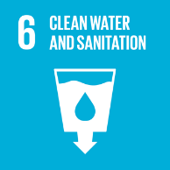 | 

Environmental Performance Monitoring and Reporting
At Tagoor Laboratories Pvt Ltd, structured monitoring and reporting systems are established to track environmental performance and ensure continuous improvement.
- Monitoring: Key environmental parameters (energy, water, waste, emissions) are monitored against defined KPIs on a monthly basis. Results are compiled into quarterly performance dashboards for management review.
- Internal Audits: Environmental compliance audits are conducted at least once a year for all applicable facilities. Audit findings are reported to senior management and corrective actions tracked to closure.
- Management Review: Senior management reviews environmental performance, audit outcomes, and target progress at least annually. Outputs from the management review feed into target-setting and policy updates.
- External Reporting: Environmental performance is disclosed through applicable external frameworks and regulatory filings.

Emergency Response & Spill Management
Preparedness
- A site-specific Emergency Response Plan (ERP) is maintained and updated annually, covering API spill scenarios, ETP failure, and stormwater contamination events.
- Dedicated spill containment kits (absorbents, neutralizing agents, personal protective equipment) are available at all API handling and storage areas.
- All employees working with or near pharmaceutical substances complete emergency response training at least once per year and participate in mock drills.
- Emergency contact lists, escalation procedures, and regulatory notification timelines are clearly posted at all operational locations.
Spill Response Protocol
- All spills are immediately contained using secondary containment systems; no API-contaminated material is permitted to reach stormwater drains, soil, or water bodies.
- Spill severity is classified as Minor (contained within work area, no environmental pathway), Moderate (reaches secondary containment), or Critical (potential or actual environmental release), with escalating response actions for each level.
- Spill-contaminated materials (absorbents, soil, protective equipment) are collected, labelled, and disposed of as hazardous pharmaceutical waste through authorized channels.
- Every spill event, regardless of severity, is recorded in the Spill Incident Register maintained by the Environment Officer.
Incident Reporting & Investigation
- Any Moderate or Critical spill triggers a formal Root Cause Analysis (RCA) within 72 hours, with corrective and preventive actions (CAPA) documented and tracked to closure.
- Critical incidents involving an actual environmental release are reported to relevant regulatory authorities (APPCB, CPCB) within the timeframes specified under applicable law.
- Lessons learned from all Moderate and Critical incidents are shared across all operational areas to prevent recurrence and drive continuous improvement.

Review Mechanism
This Responsible Management of Pharmaceutical Discharges Policy is subject to periodic evaluation by Environmental Officer at least once every two years or earlier if required due to regulatory changes, operational developments, or stakeholder feedback to ensure its continued relevance, effectiveness, and alignment with evolving regulatory requirements and organizational priorities.
The review encompasses an assessment of compliance status, progress against established environmental targets, and inputs from relevant stakeholders. Based on this evaluation, necessary updates are incorporated to strengthen the policy framework and ensure alignment with current regulations, industry best practices, and the Company’s commitment to continuous environmental improvement.

Prepared By:

Approved By:

Last Review date: 01/01/2026

Next Review date: 01/01/2028

Employee Acknowledgement & Commitment Declaration

I, the undersigned employee of Tagoor Laboratories Pvt. Ltd., hereby acknowledge my participation in the Company’s Responsible Management of Pharmaceutical Discharges Framework and confirm the following commitments:

1. Awareness Confirmation
☐ I confirm that I have received the Responsible Management of Pharmaceutical Discharges Policy
☐ I have read and understood its purpose, scope, and requirements
☐ I understand how it applies to my role, especially in handling APIs and related processes

2. Commitment to Compliance
☐ I agree to comply with all applicable procedures and controls related to pharmaceutical discharges
☐ I will follow safe and responsible practices in handling Active Pharmaceutical Ingredients (APIs) and associated materials
☐ I will support the Company’s efforts to meet environmental and regulatory requirements related to API discharge

3. Active Participation
☐ I will participate in training and awareness programs related to API handling and discharge management
☐ I will support initiatives aimed at minimizing pharmaceutical discharges and improving effluent management
☐ I will contribute to improving discharge control practices in my area of work

4. Responsibility & Reporting
☐ I will report any risks, incidents, spills, or non-compliance related to pharmaceutical discharges without delay
☐I will communicate improvement opportunities related to API discharge control to the Environmental officer
☐ I understand my role in preventing environmental contamination through responsible handling of APIs

5. Continuous Improvement Mindset
☐ I acknowledge that responsible management of pharmaceutical discharges is an ongoing responsibility
☐ I commit to supporting continuous improvement in API discharge control and environmental protection practices

Employee Name:

Acknowledgement Date:

Signature:

